***INTERNSHIP PROJECT***

**Project Details:**

Project- 1: - Authentication Bypass  
  
1) Take some random websites using Google hacking database and enter into their admin panel using SQL Injections (Manual and using a tool called burp suite)  
  
2) Show some live cameras using Google hacking database.

Project- 2_ System Hacking

Password attack  
  
1. Hydra  
2. auxiliary Module  
3. NSE Scripts  
4. John the ripper  
5. Password generating using Crunch

**Project -2: - SYSTEM HACKING**

**Password Attack: -**

**1)Hydra**

**Steps:**

1. Created the .txt file for username and password in Kali Linux

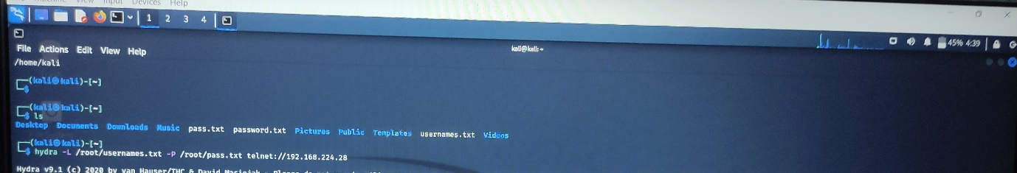

1. Hydra is the default tool in Kali Linux which is used to crack the username and password of the device that we provide through IP address. Here I have used IP address of Metaspoiltable 2
2. Command is:

**hydra -L (location of username.txt) -P (location of password.txt)** [**telnet:// IP**](telnet://%20IP) **address of device**

1. Instead of telnet we can use any open port as ssh, ssm, ftp, url and many more

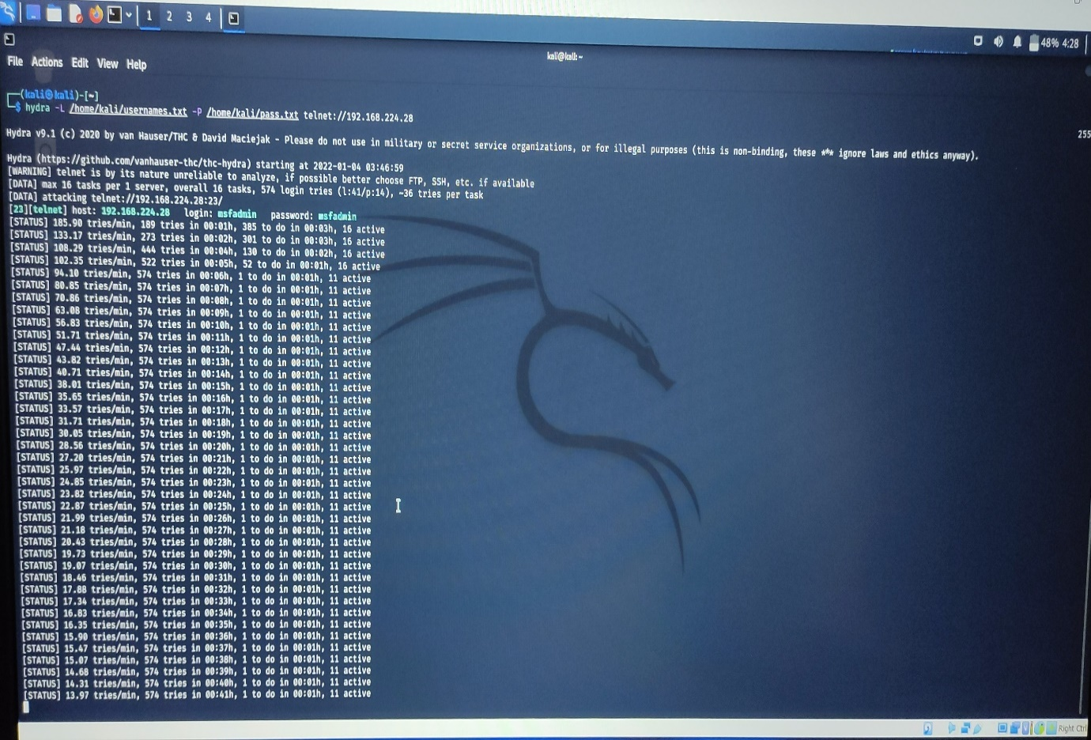

Using hydra tool, I have found one username and password successfully.

Login: msfadmin password: msfadmin

1. **Auxiliary Module:**

Auxiliary Module are available in Metaspoiltable Framework. There are almost 1155 auxiliary module present in Metasploit. All we can do in Kali Linux easily.

**Steps: -**

1. Need to create two .txt file for username and password.
2. There are number of Auxiliary Module of open port like telnet, ssh, ssm, url, ftp etc and many more. We can select any one from this. Use below command to get list of auxiliary modules

* **msfconsole**
* **Use auxiliary**

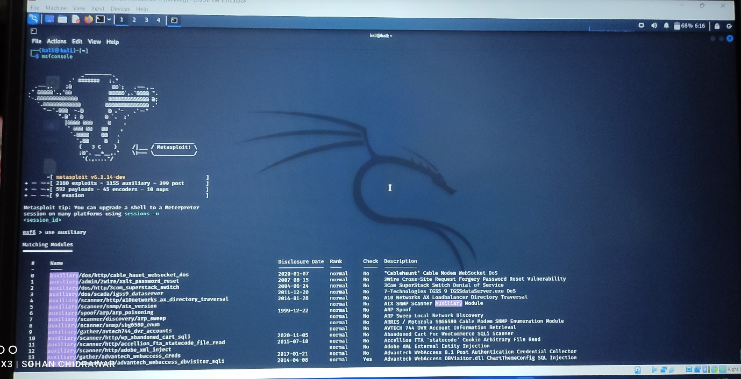

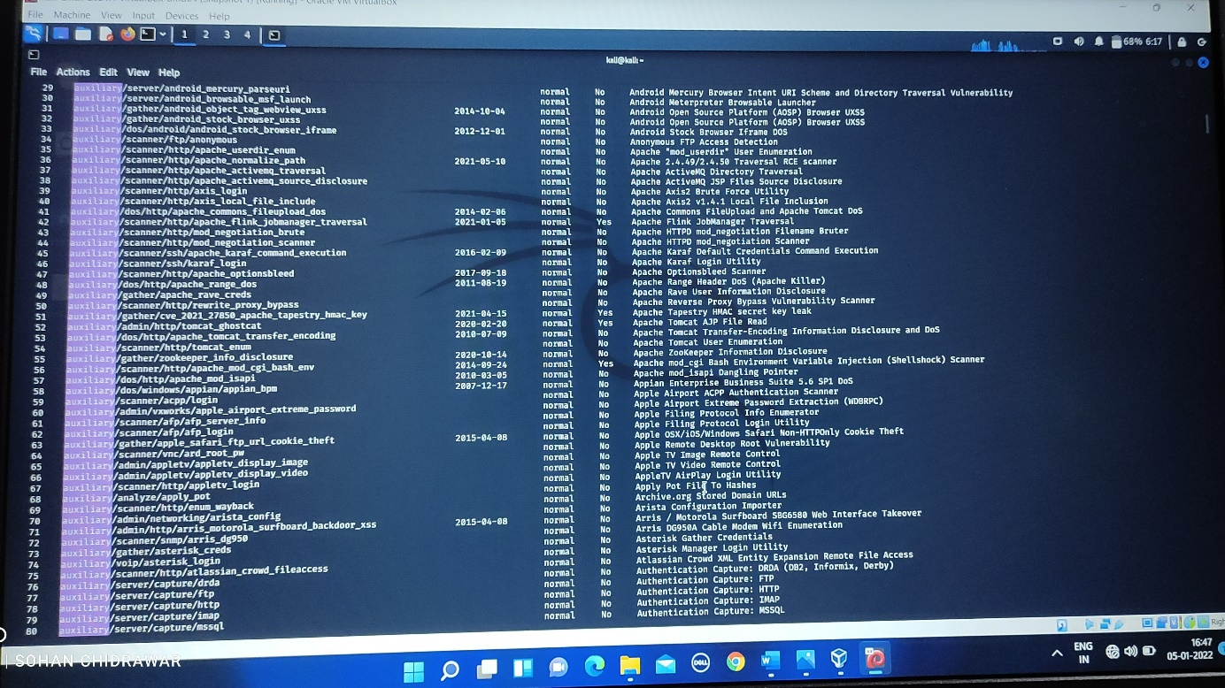

Auxiliary Modules

1. Hear I have use Open port 23 Telnet. Use below command

* use auxiliary/scanner/telnet_

Then you can see various output regarding telnet_ as login, version, encrypt_overflow

* use auxiliary/scanner/telnet_login
* show options

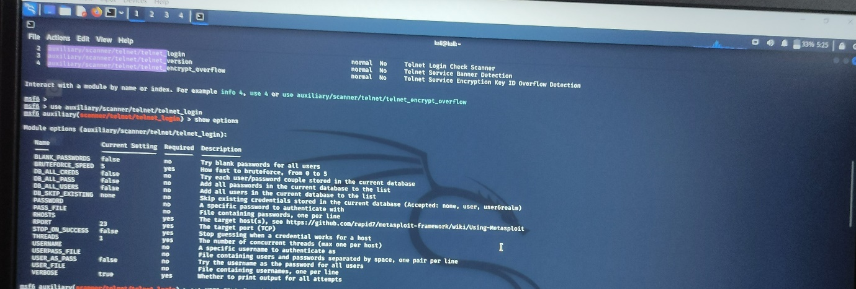

1. Here we want to set RHOSTS, USER_FILE, and PASS_FILE and run.

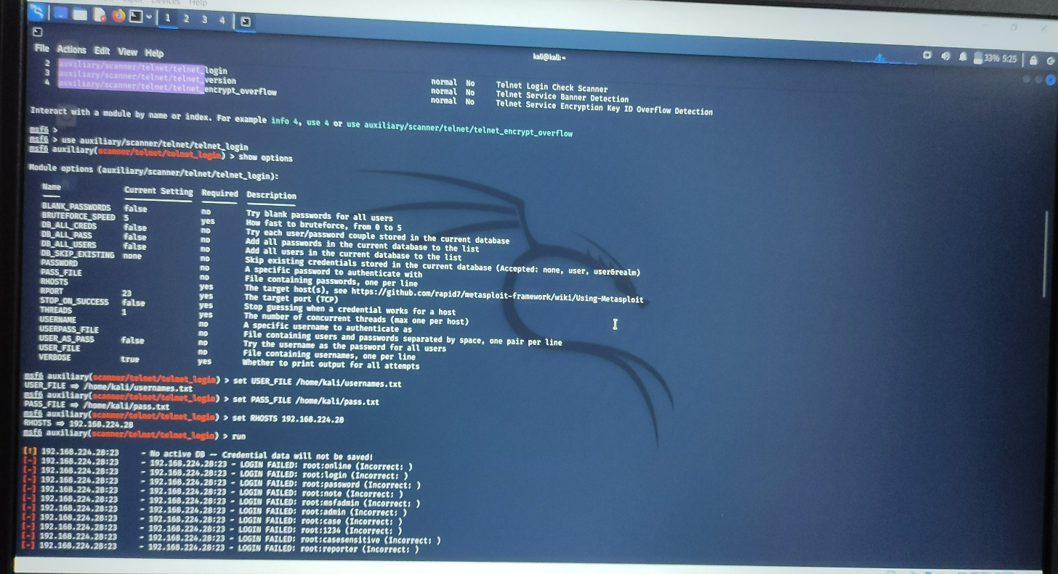

1. After using run command, it will show the possible output. Here are some snapshoot of the process.

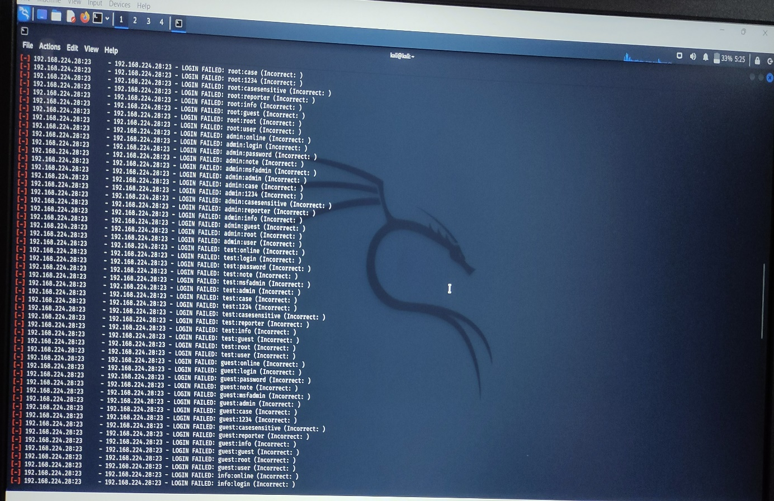

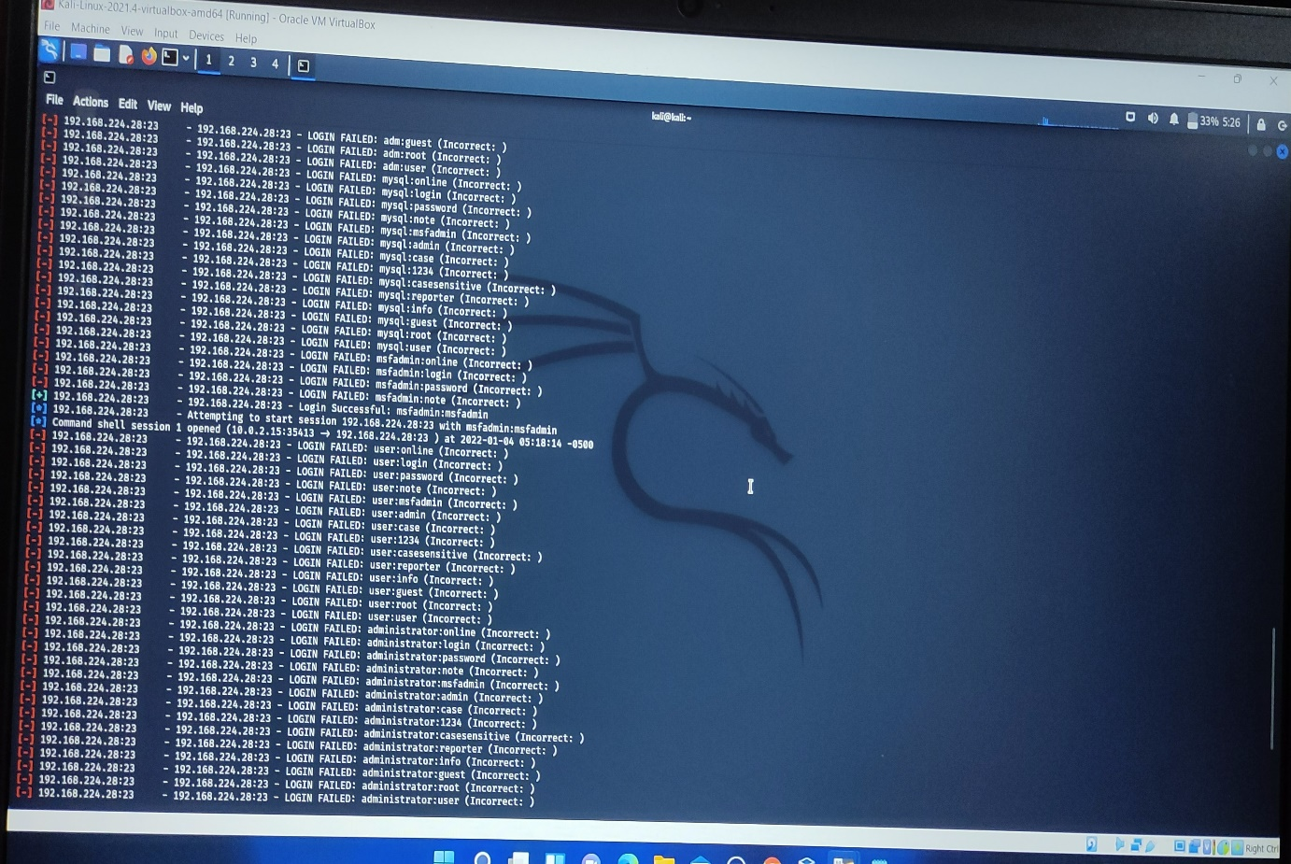

Here we found one username and password which have done login successfully

ID: msfadmin

Password: msfadmin

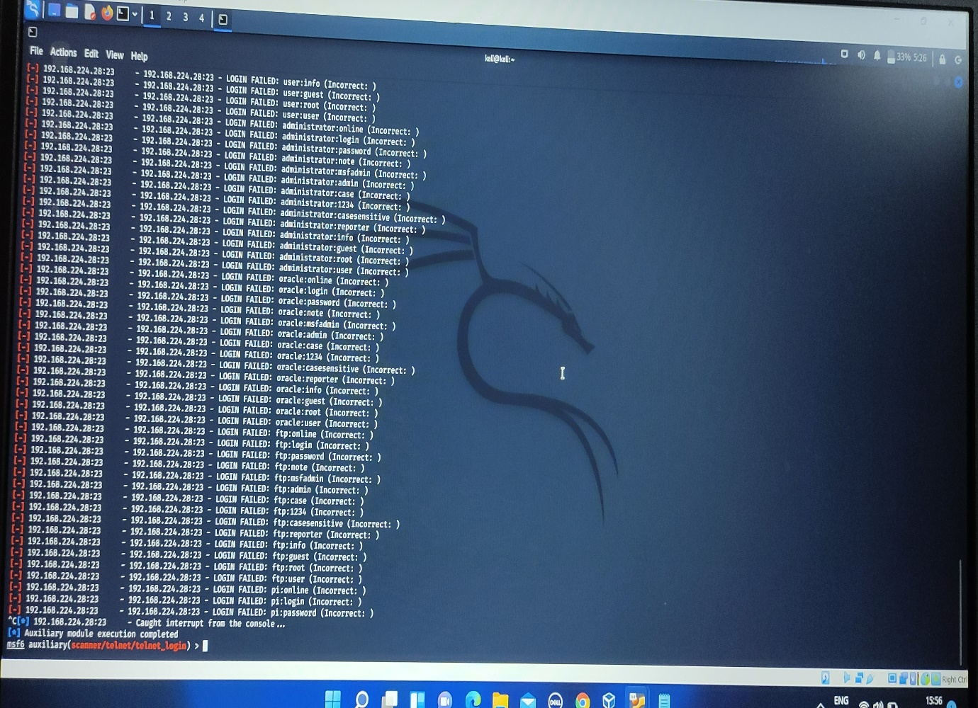

1. **NSE SCRIPT: -**

Here, creation of .txt file is not required. Here we use inbuilt file given in Kali Linux.

Nmap script is use to crack the password of given device by providing the IP address.

**Steps: -**

1. Use the given nmap script using following command and check the given number of scripts.

* **cd /usr/share/nmap/scripts**
* **ls**

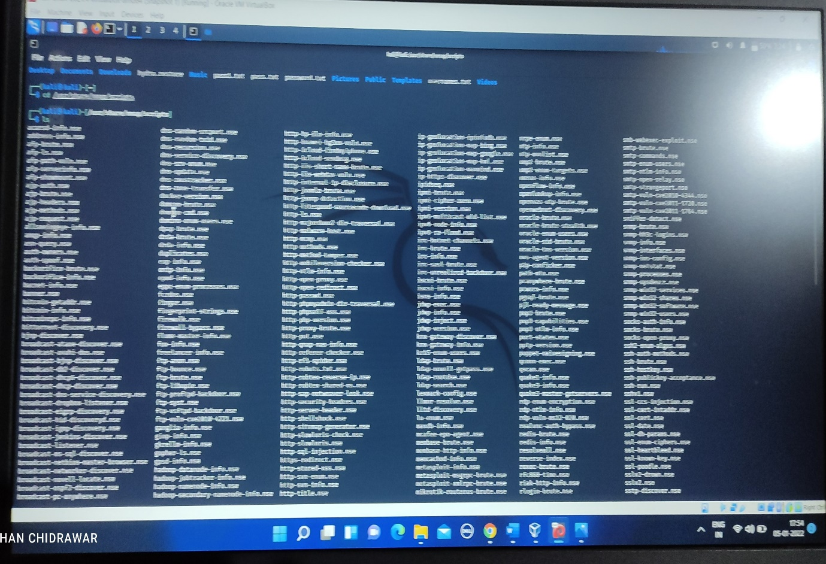

1. I have done password attack with telnet and ssh both.
2. Use below command to crack password with telnet (port number 23).

After getting access to /usr/share/nmap/scripts

* ls -l | grep telnet

various options with telnet are shown

* nmap --script telnet-brute.nse -p (port number) (IP address)

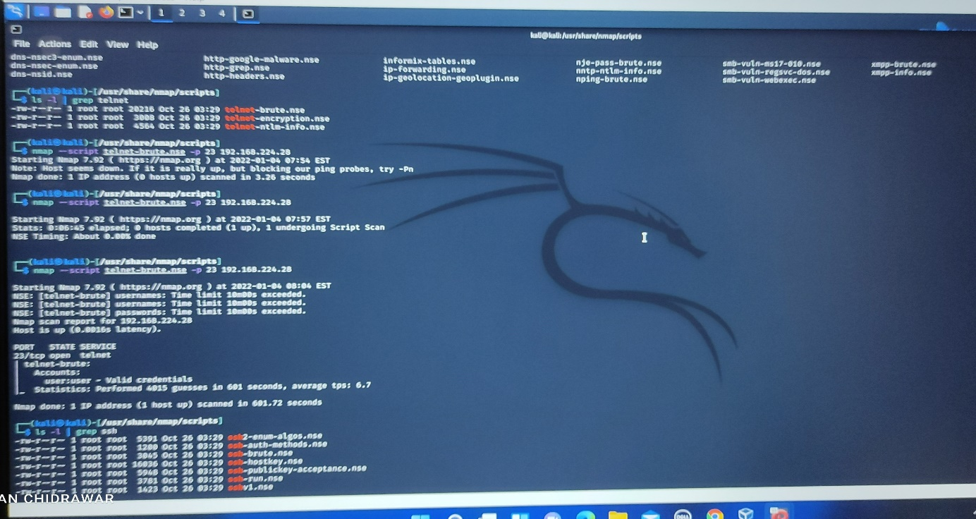

Here we found the valid credential

1. Use below command to crack password with ssh (port number 22).

nmap - -script ssh-brute.nse -p 22 IP address of target

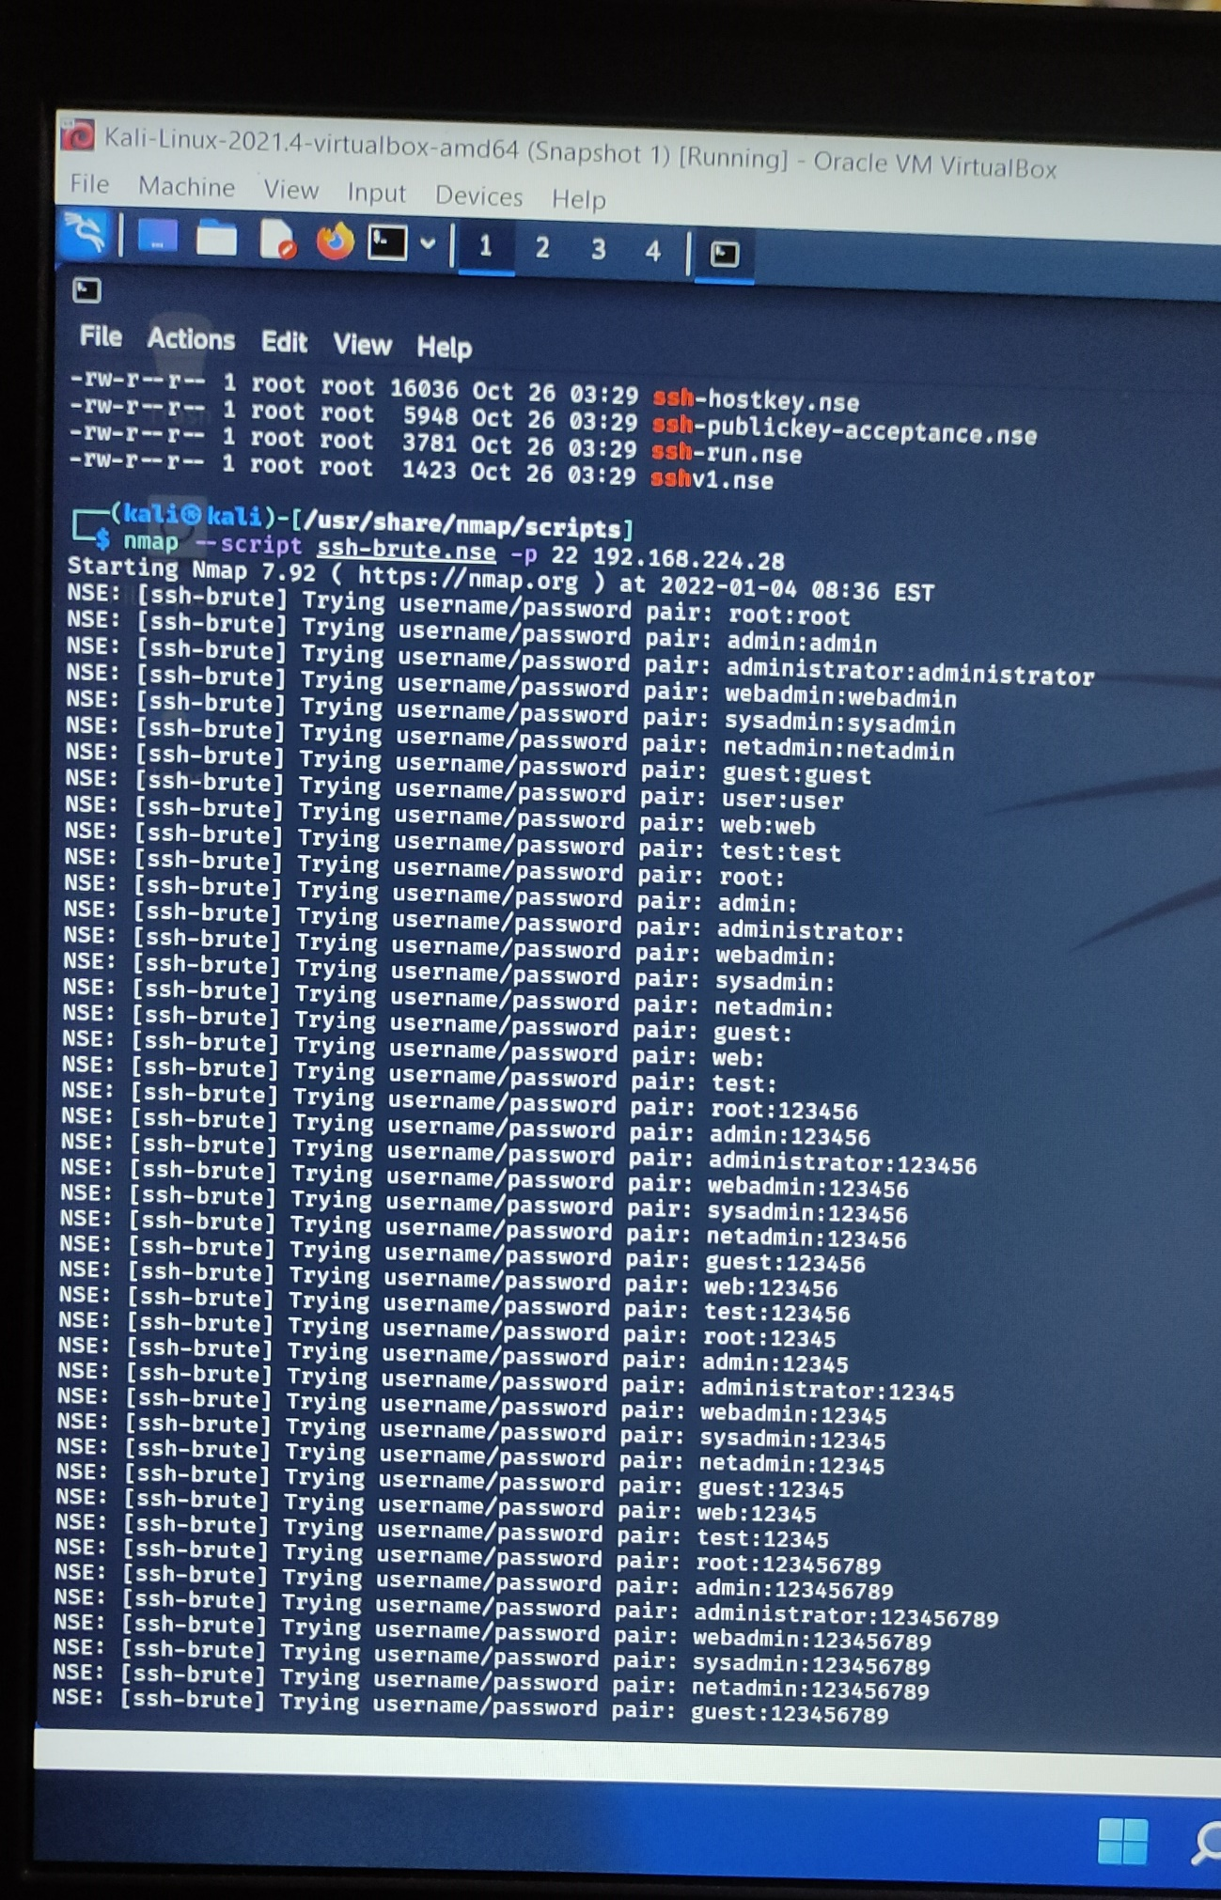

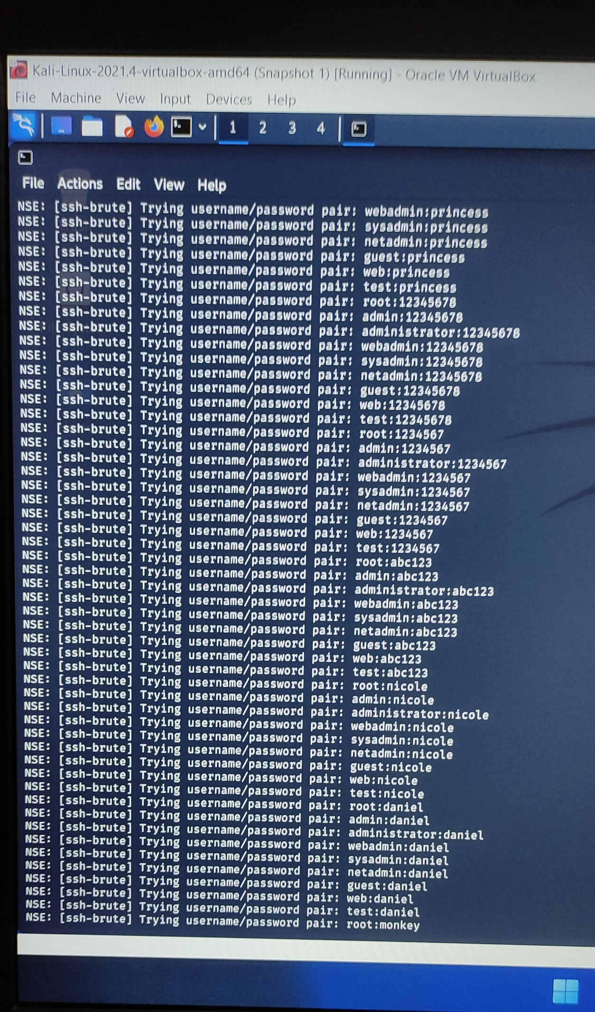

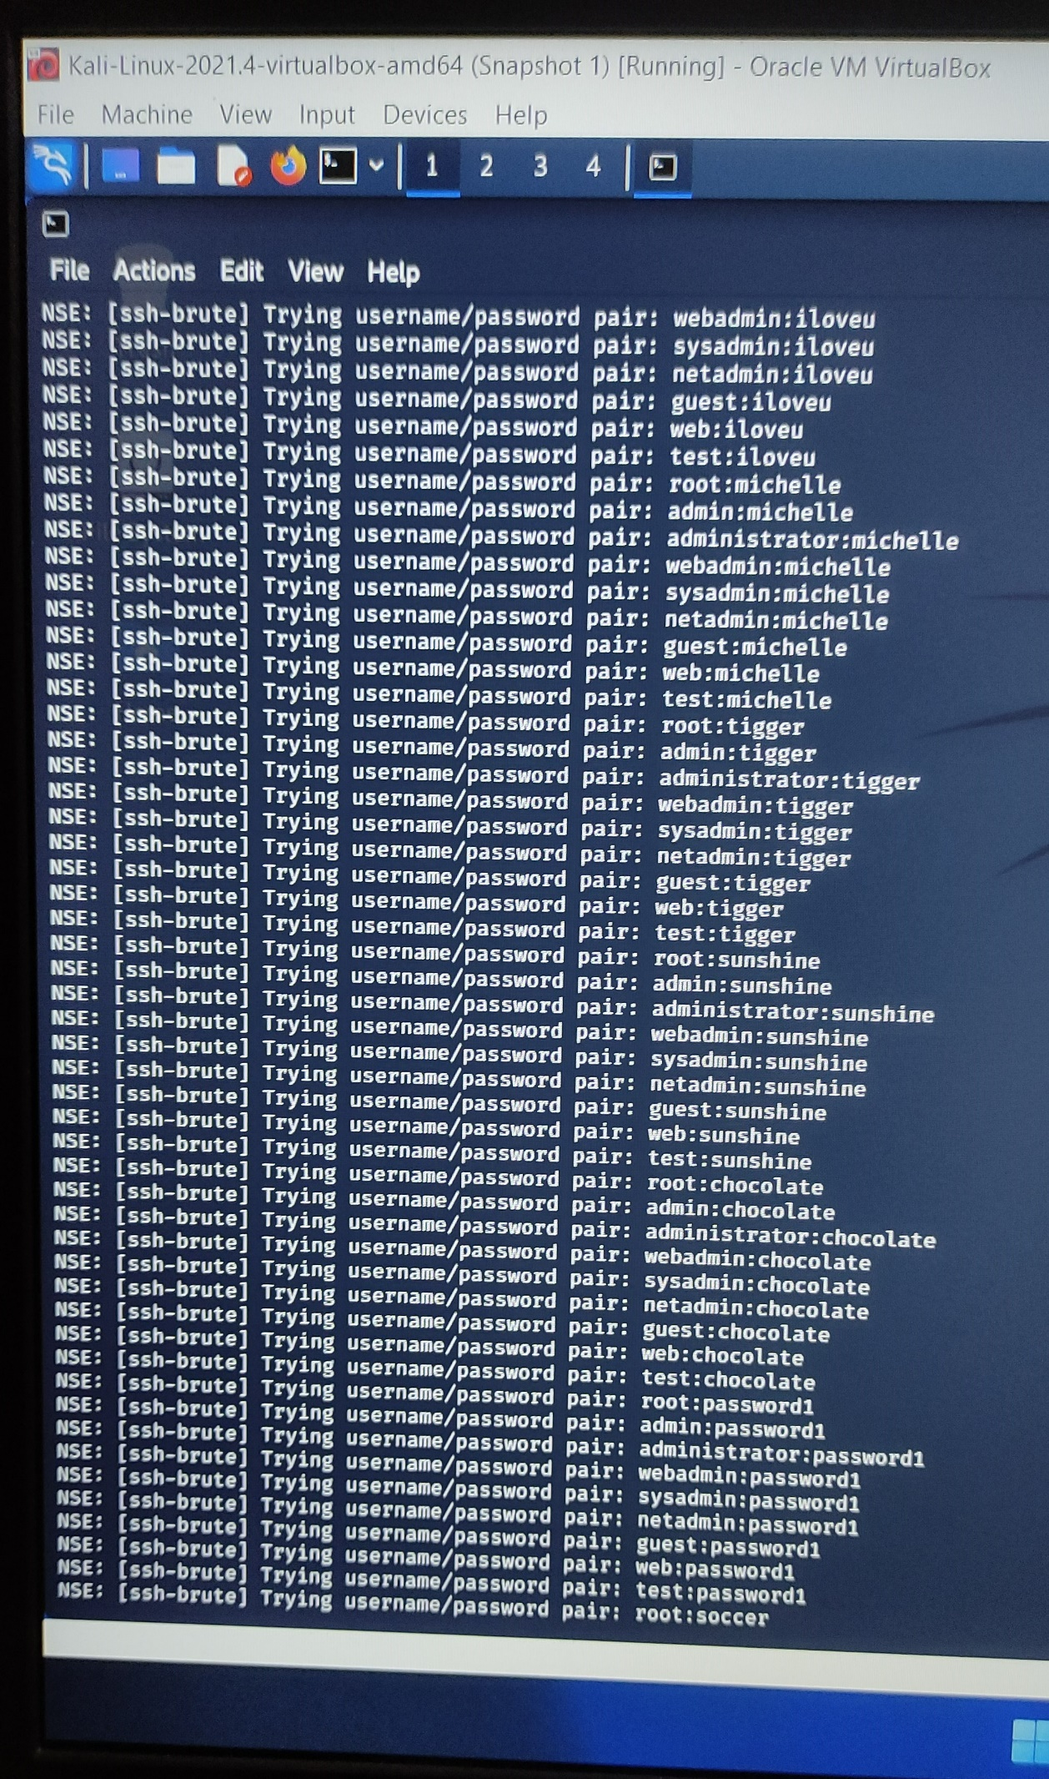

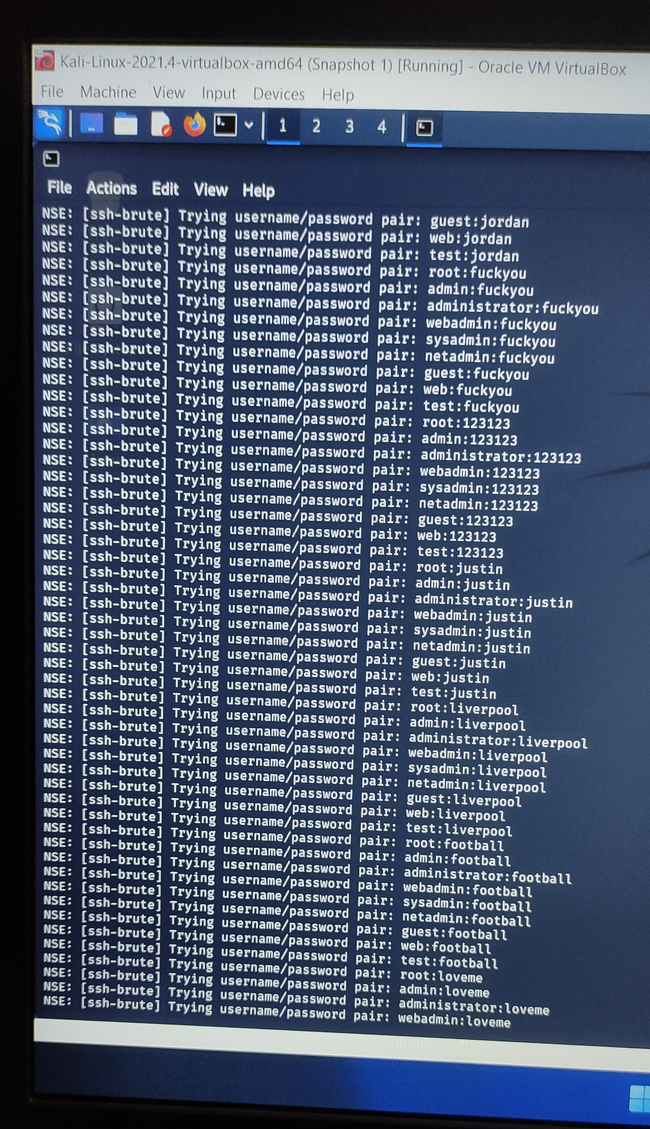

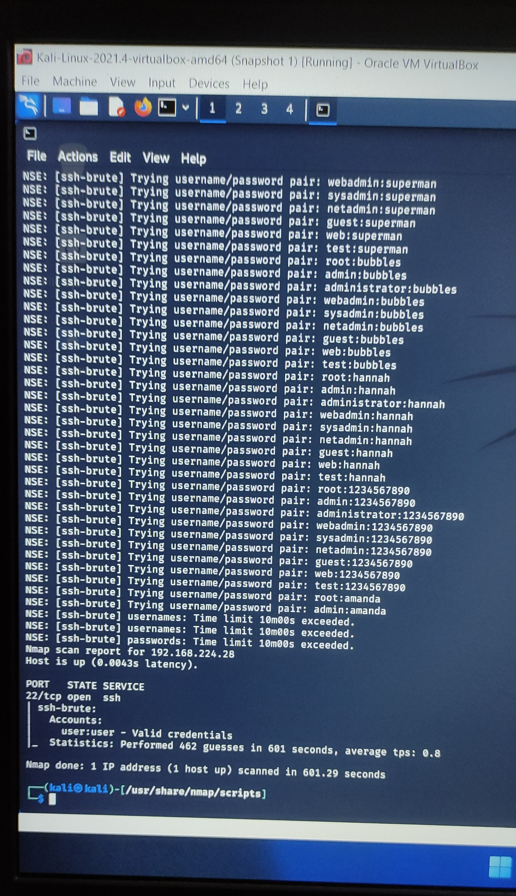

Valid Credential found!!

1. John the Ripple: - John the Ripple is a fast password cracker, it is used to crack the hashes.

* Steps to crack the hash value to get the password are

1. Copy all the hash value in one .txt file.
2. In Kali Linux use following command to crack the hashes.

john (name of file)

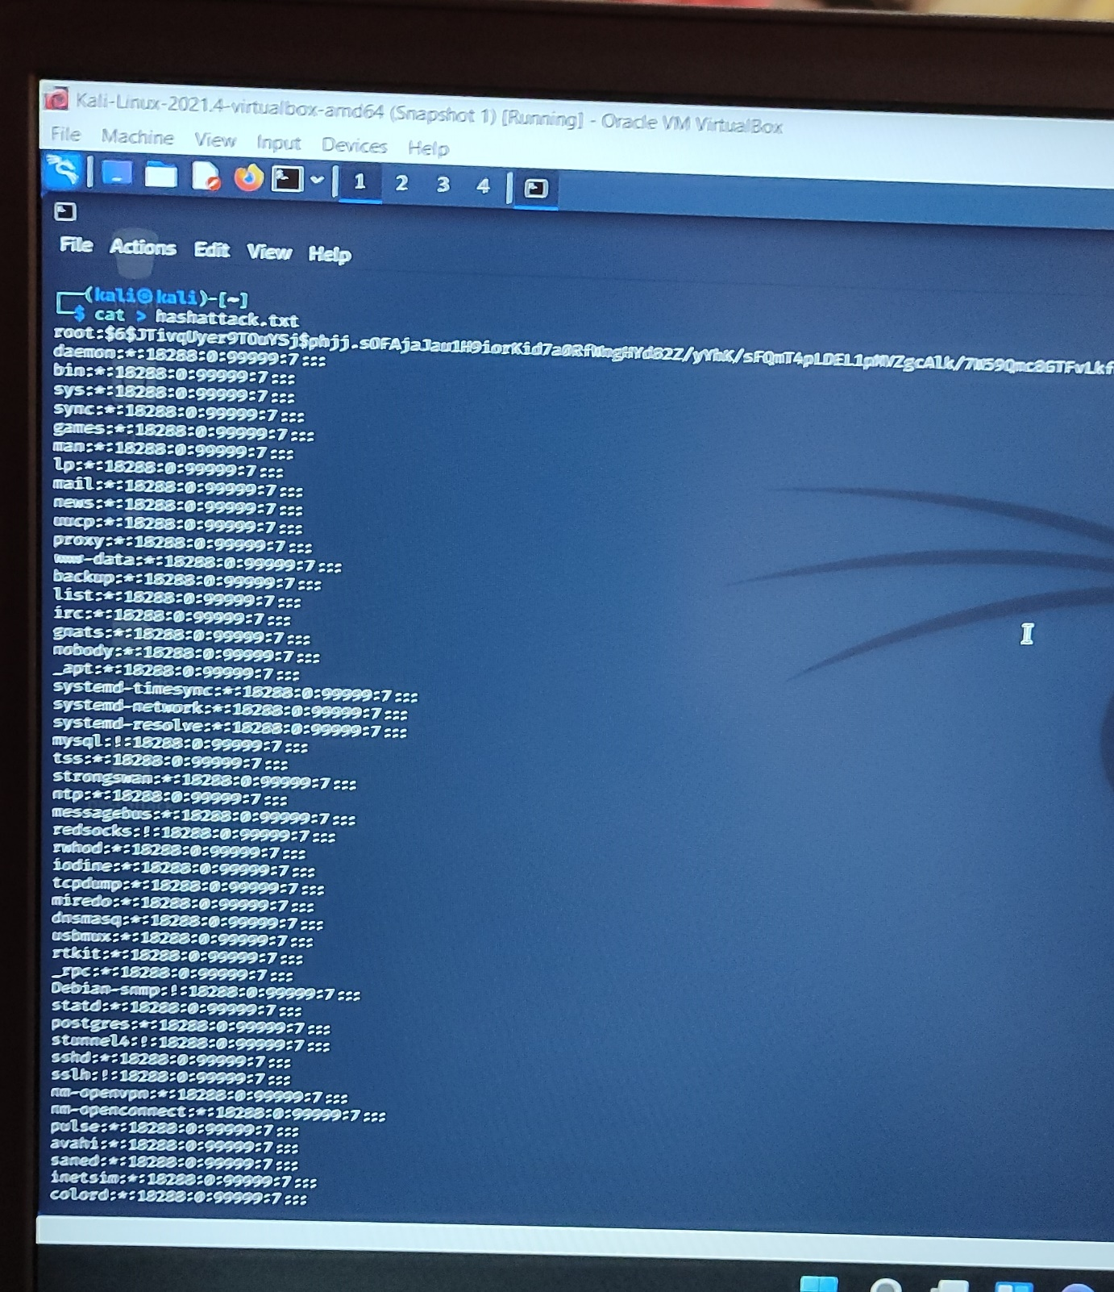

File name in which hashes are stored

Copied all hash value in file name hashattack.txt

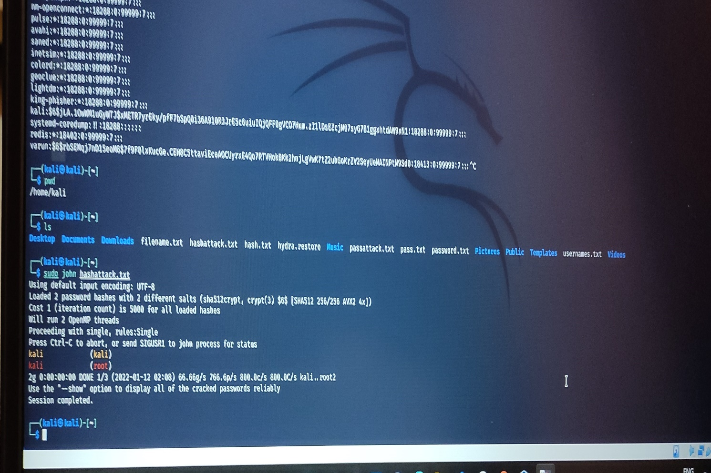

Command to crack the hashes

Command: - sudo john hashattack.txt

**This above two passwords have been found after cracking the hashes using John the Ripple.**

* According to reference video, they told to crack the hashes provided in shadow file in Kali Linux. Following the steps: -

1. Copied all hash value from shadow file given in Kali Linux. Navigate /etc/shadow to find dhadow.txt file
2. Make .txt file and paste all hash value.
3. Command to crack the hash

john - -show (filename in which hash value are copy)

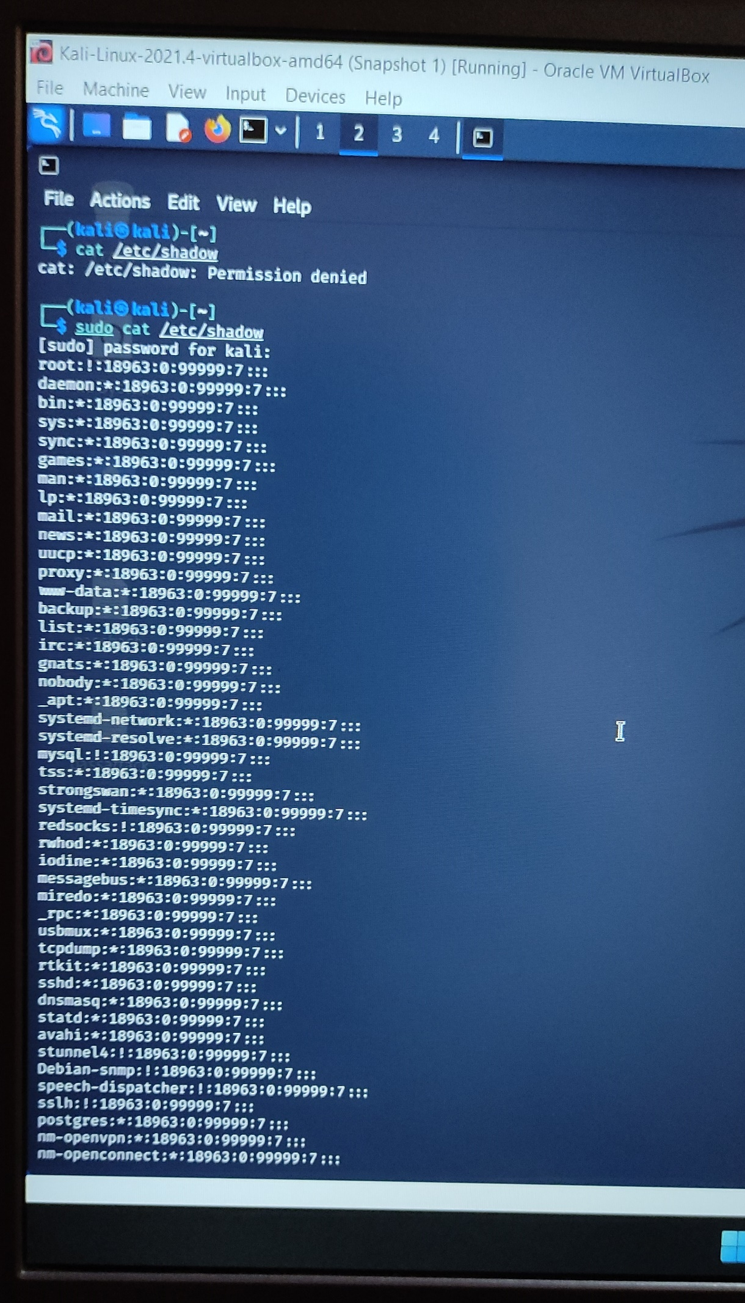



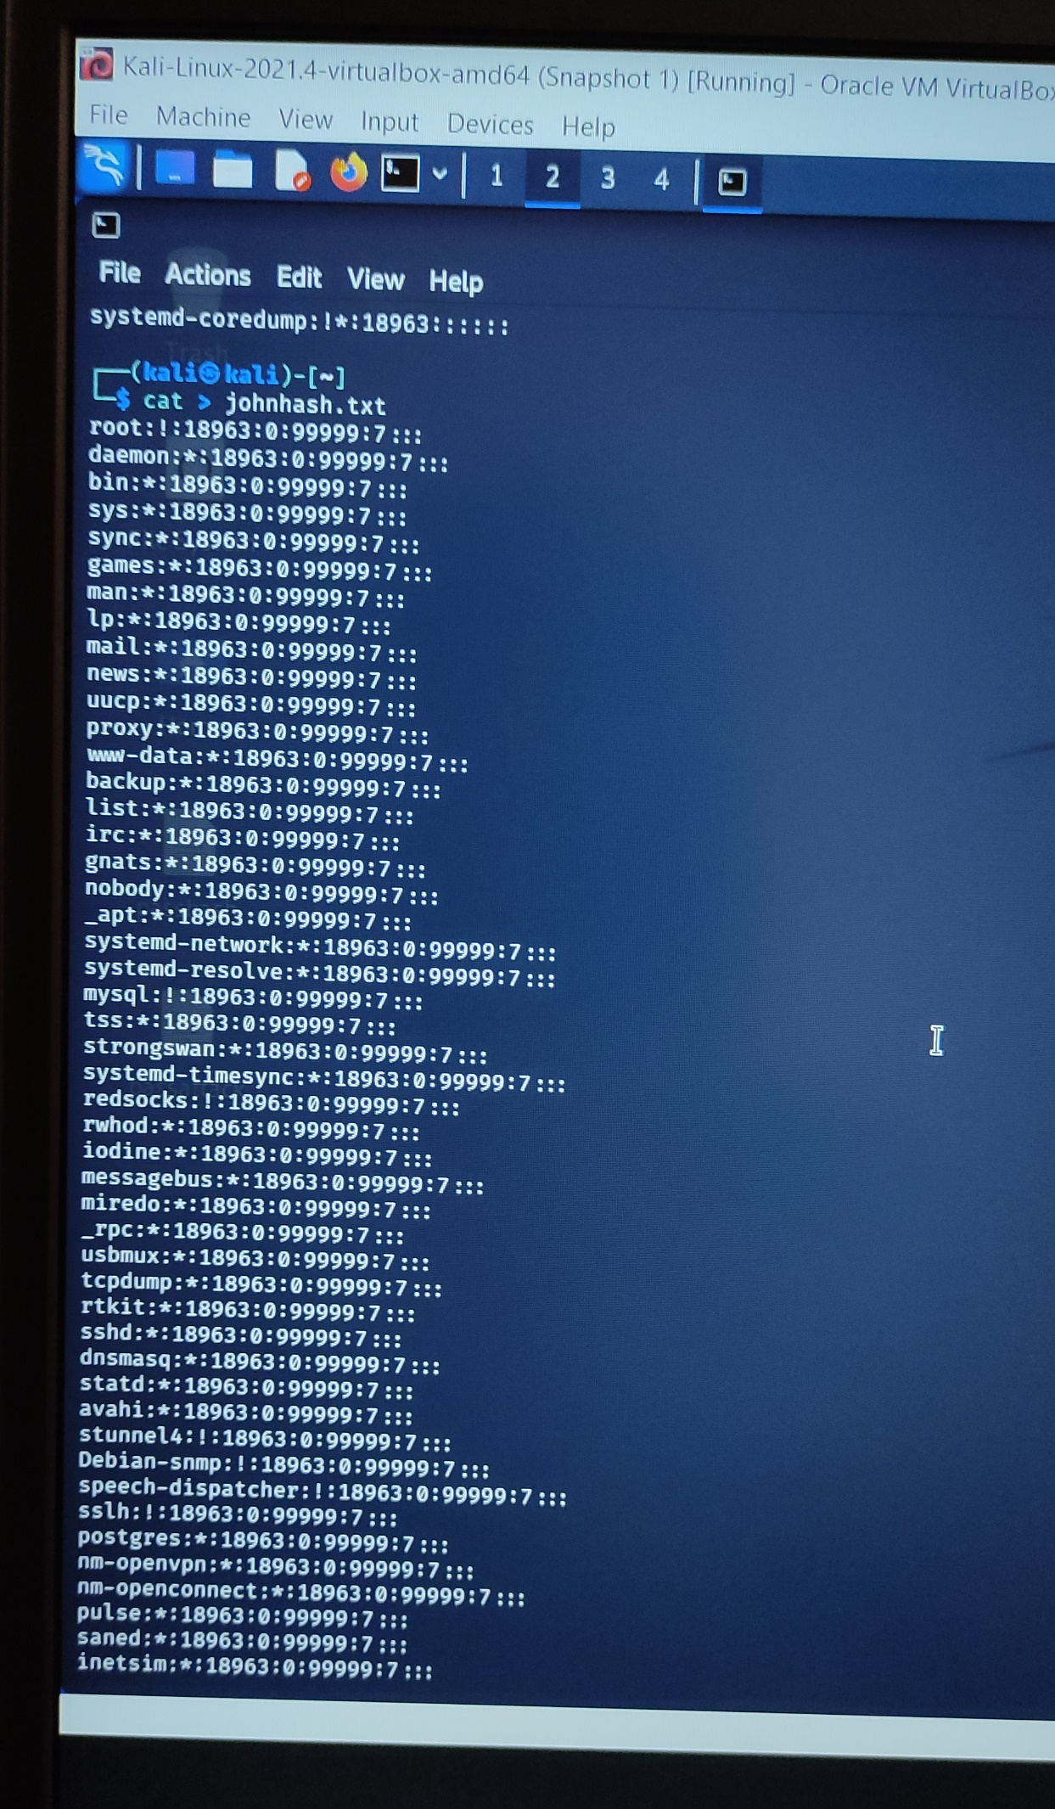

All hash value is copied to johnhash.txt file

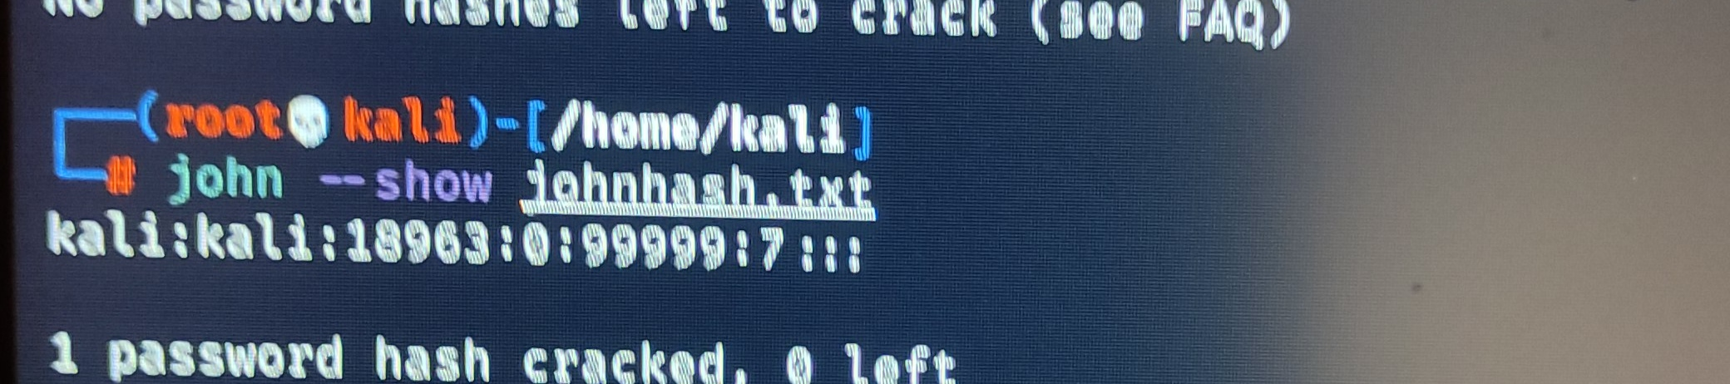

**Kali is username and password for this hash value.**

**Here we have found only one username and password.**

1. Or we can directly give the access of shadow file in command without copying all hash value in a file. For that below command is use

john /etc/shadow - -format-crypt

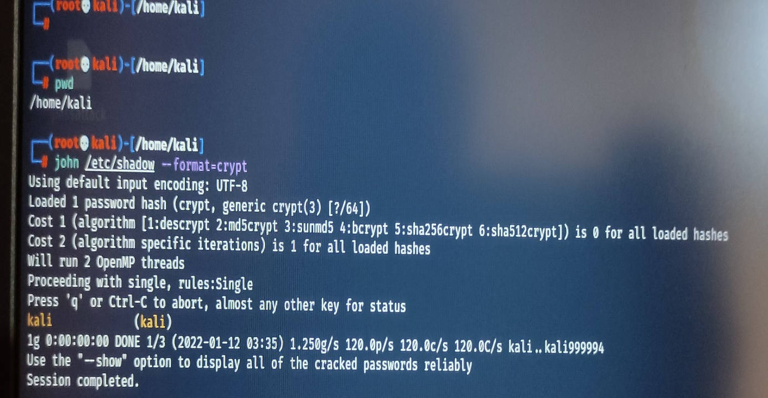

**Output after cracking the hashes**

1. Password generating using Crunch: -

Crunch tool is default tool in Kali Linux which is use to generate the password with help of alphabet, number and special symbols.

It is type of brute force. Brute-force Crunch is a technique of generating all possible combination of character and using them for password cracking.

Crunch is one of most powerful tools used for creating a list of passwords.

* Command to create list of passwords is

crunch 6 6 abcde123ASDF -o file.txt

Alphabet, number from which password will form

Name of file to store all possible combination of password

Minimum length of password

Maximum length of password

Some of screenshot of file containing list of passwords created using crunch: -

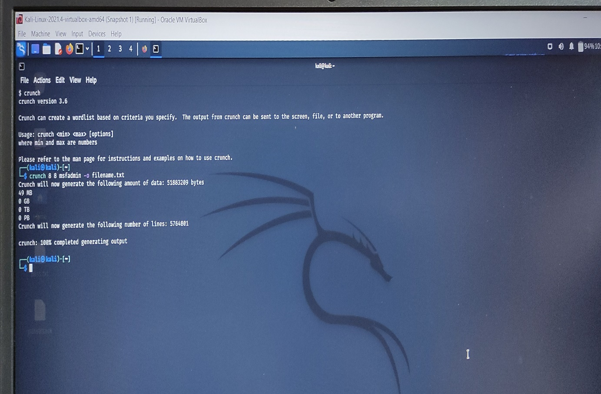

Command

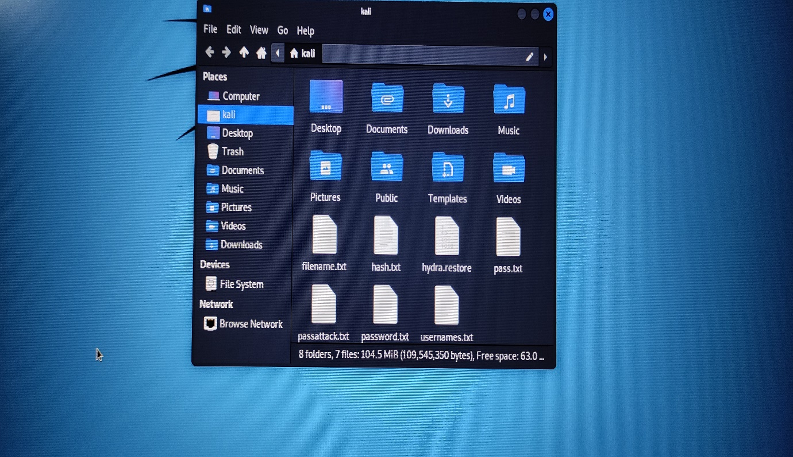

File created successfully using crunch.

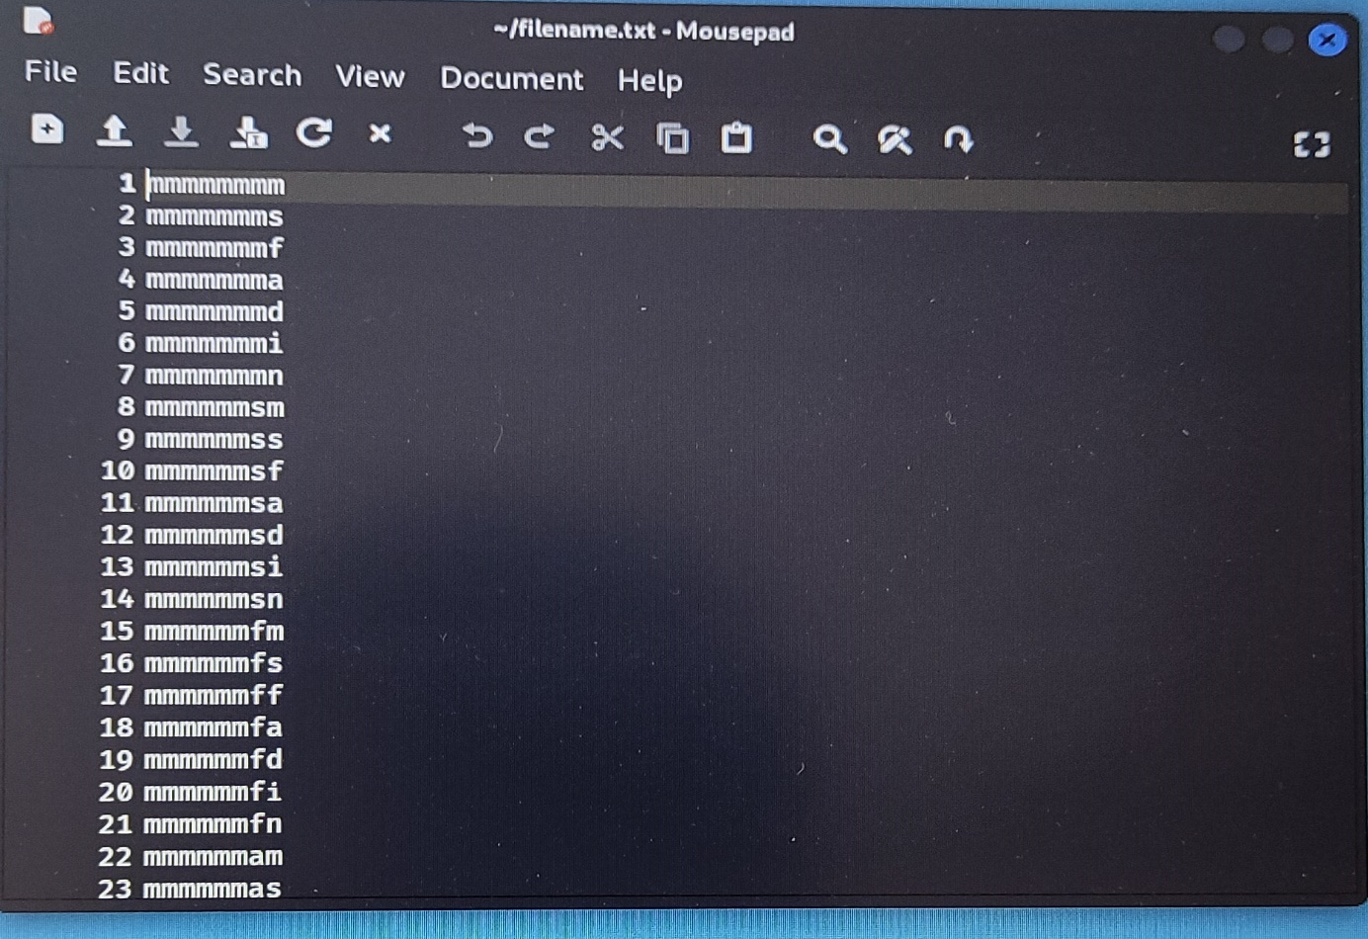

Password are listed out

* Now we can use this file for password cracking.

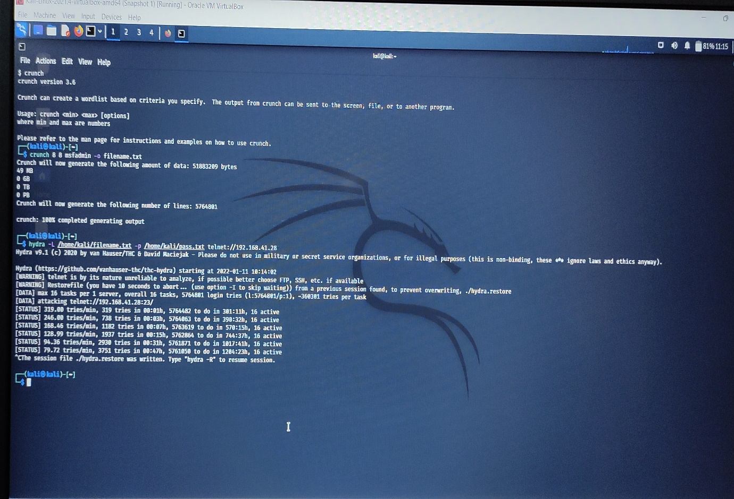

Here I have tried to use hydra for password cracking.

* Crunch can also be used to generate more customised password lists.

Say a password to be generated meet the following condition, first character is Caps, next two chars are lower case, followed by two special character and the by three numbers. Total 8 chars.

Example: Acd@#345 or Xyt&*987

* Command use in crunch to make such list of passwords is

crunch 8 8 -t ,@@^^%%%

**, is Uppercase**

**@ is Lowercase**

Maximum length of password

Minimum length of password

**^ is Special Character**

**% is Numeric**

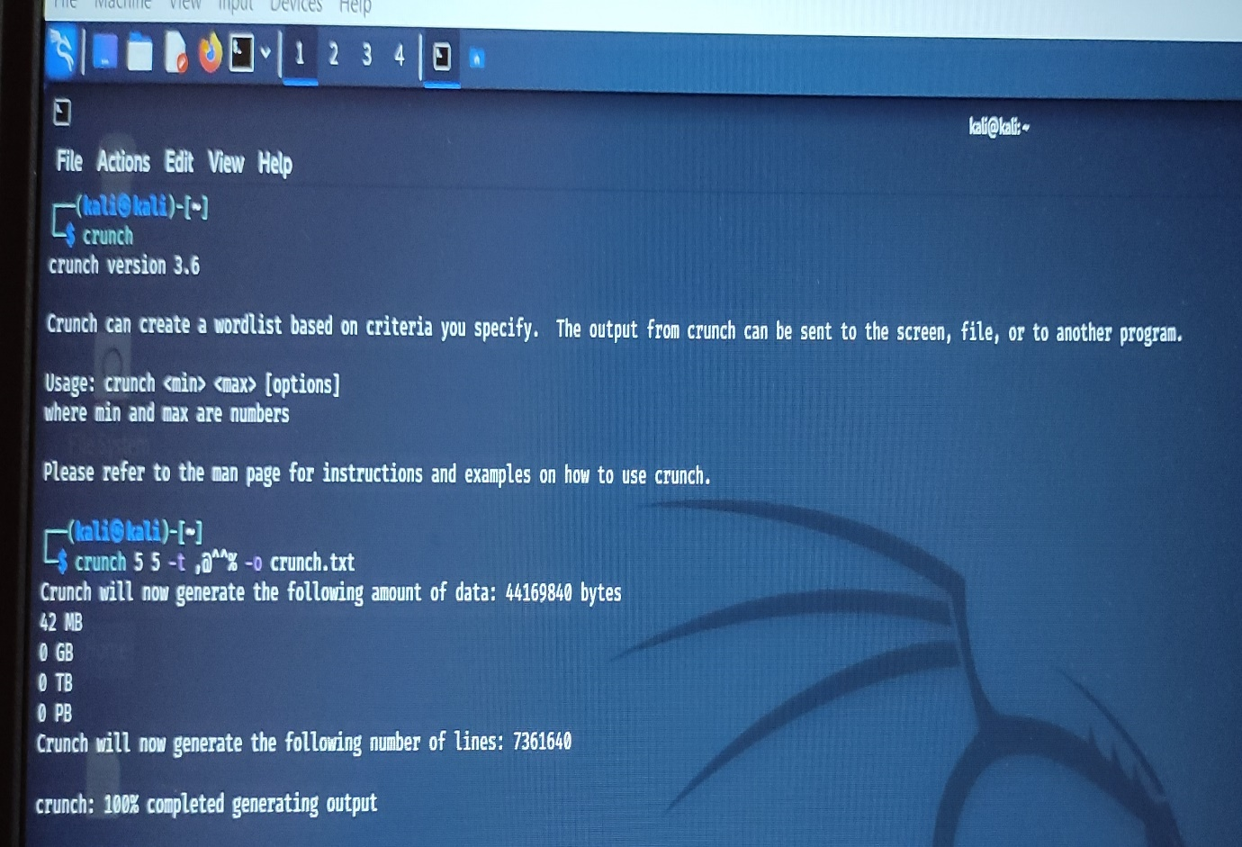

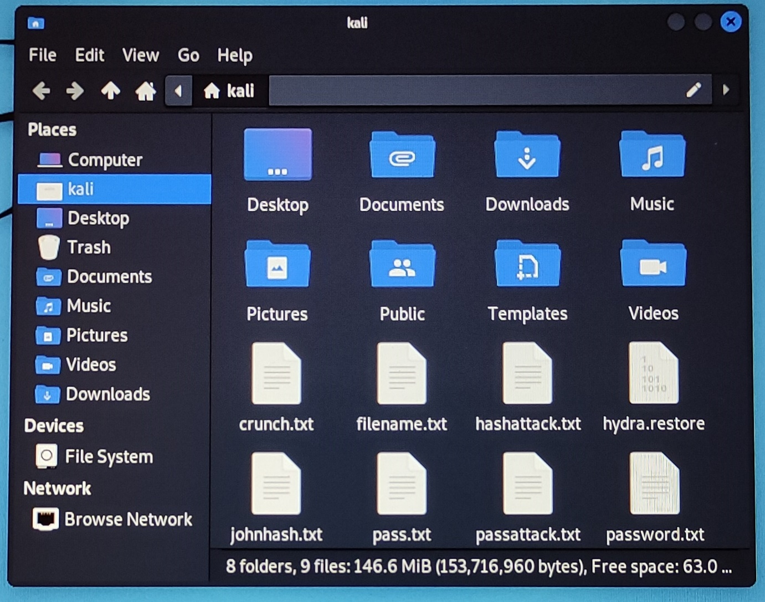

**Done by: Sohan Sudhir Chidrawar**

File created

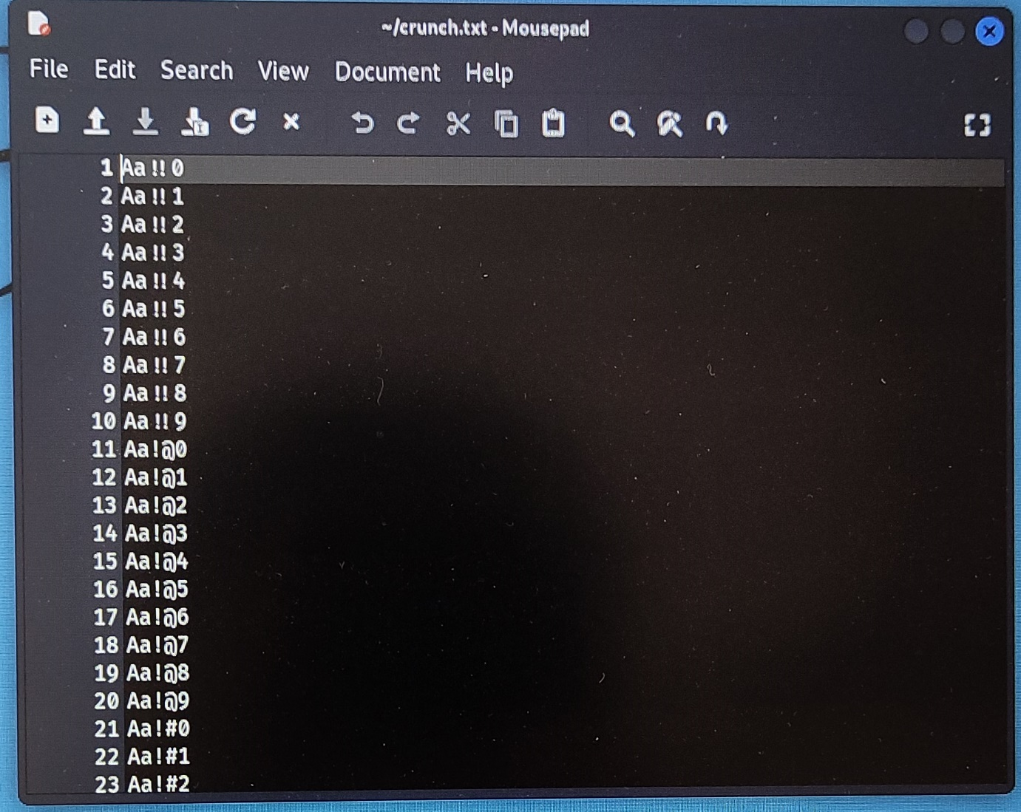

Password are listed out

Done by: - Sohan Sudhir Chidrawar